**Assignment 1**

When Power BI is installed, it launches a welcome screen. This screen is used to launch different options related to get data, enrich the existing data models, create reports as well as publish and share reports.

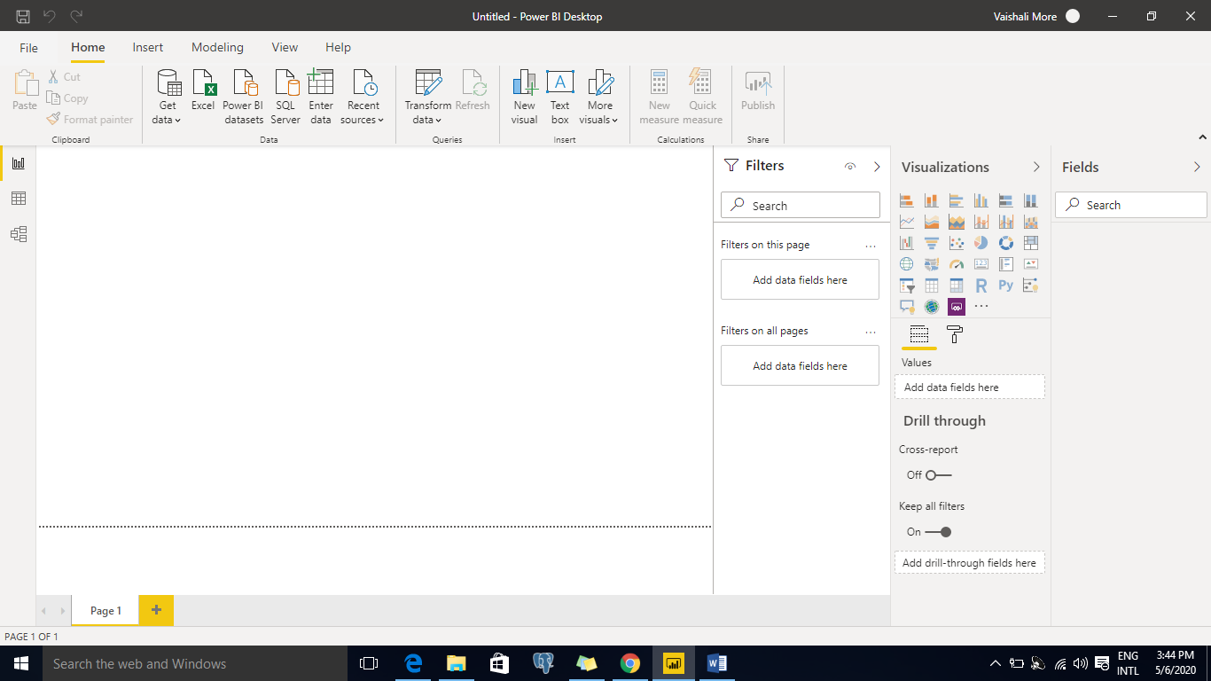

To create data model in Power BI, you need to add all data sources in Power BI new report option. To add a data source, go to the Get data option. Then, select the data source you want to connect and click the Connect button.

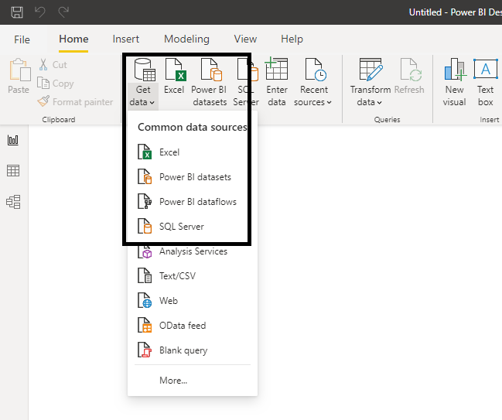

Once you add a data source, it is presented on the right side bar. In the following image, we have used 3 xls file to import data – Emp Master, Product Master & Sales Data.

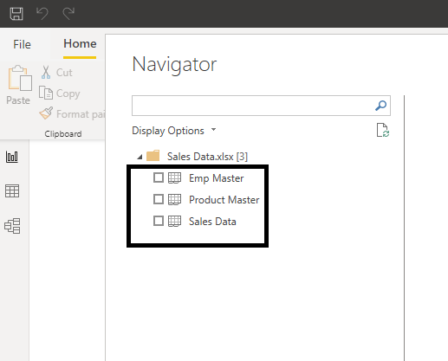

After completing your selection, you have three options – Load, Edit or Cancel.

• Load, loads the data from the source into Power BI Desktop for you to start creating reports.

• Transform Data allows you to perform data shaping operations such as merging columns, adding additional columns, changing data types of columns as well as bringing in additional data.

• Cancel gets you back to the main canvas.

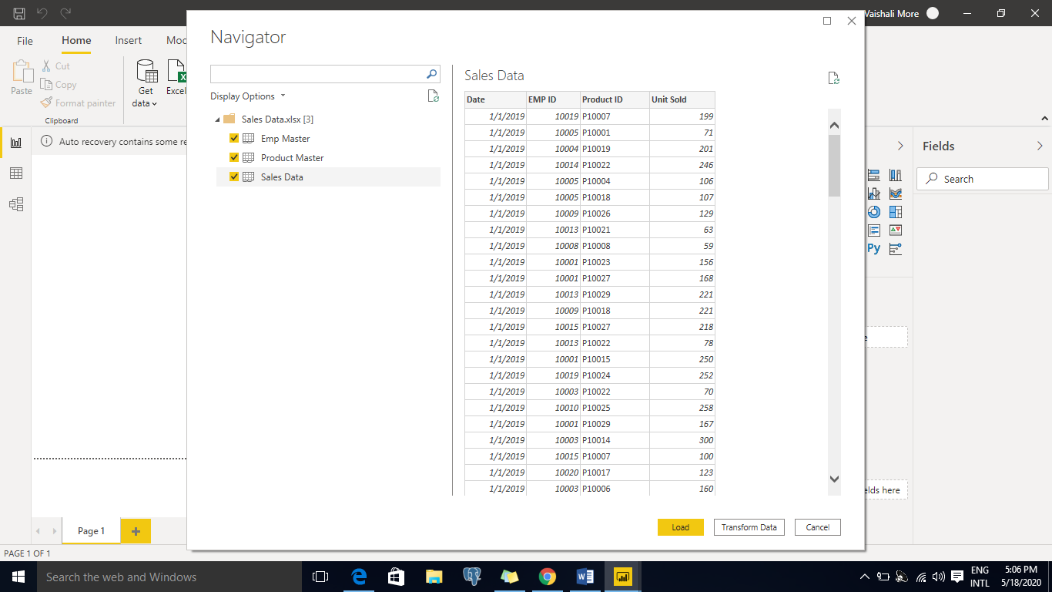

Click Transform Data as shown in the screenshot. A new window opens.

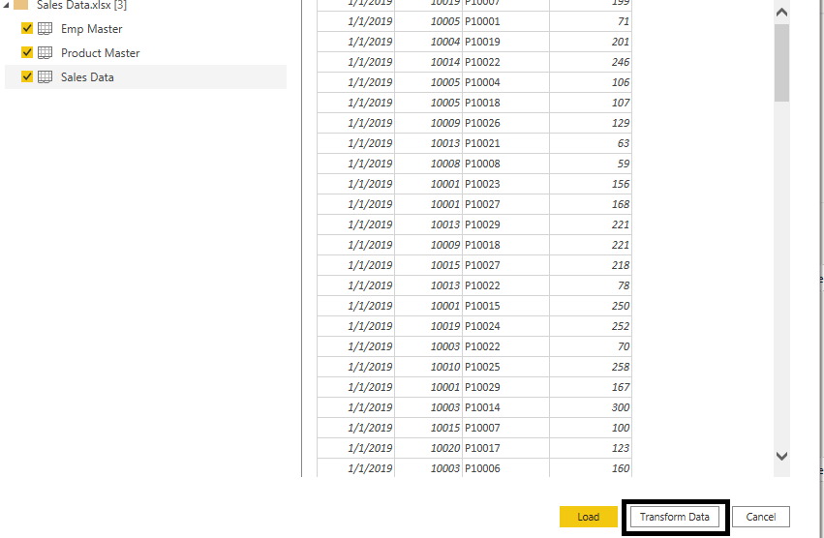

**Power Query Editor:**

The **Query Editor in Power BI** is used to transform or edit data files before they are actually loaded into the **Power BI**. The **Query Editor** plays the role of an intermediate data container where you can modify data by selecting rows and columns, splitting rows and columns, pivoting and unpivoting columns, etc

In **Query Settings**, the **Applied Steps** list reflects any shaping steps applied to the data. To remove a step from the shaping process, select the **X** to the left of the step.

In the following image, the **Applied Steps** list reflects the added steps so far:

* + **Source**: Connecting to the Excel file.
  + **Navigation**: Selecting the table.
  + **Promoted Headers**: Selecting 1st row has as header of the column
  + **Changed Type**: Changing text-based number columns from Text to Whole Number and date data type for date columns.

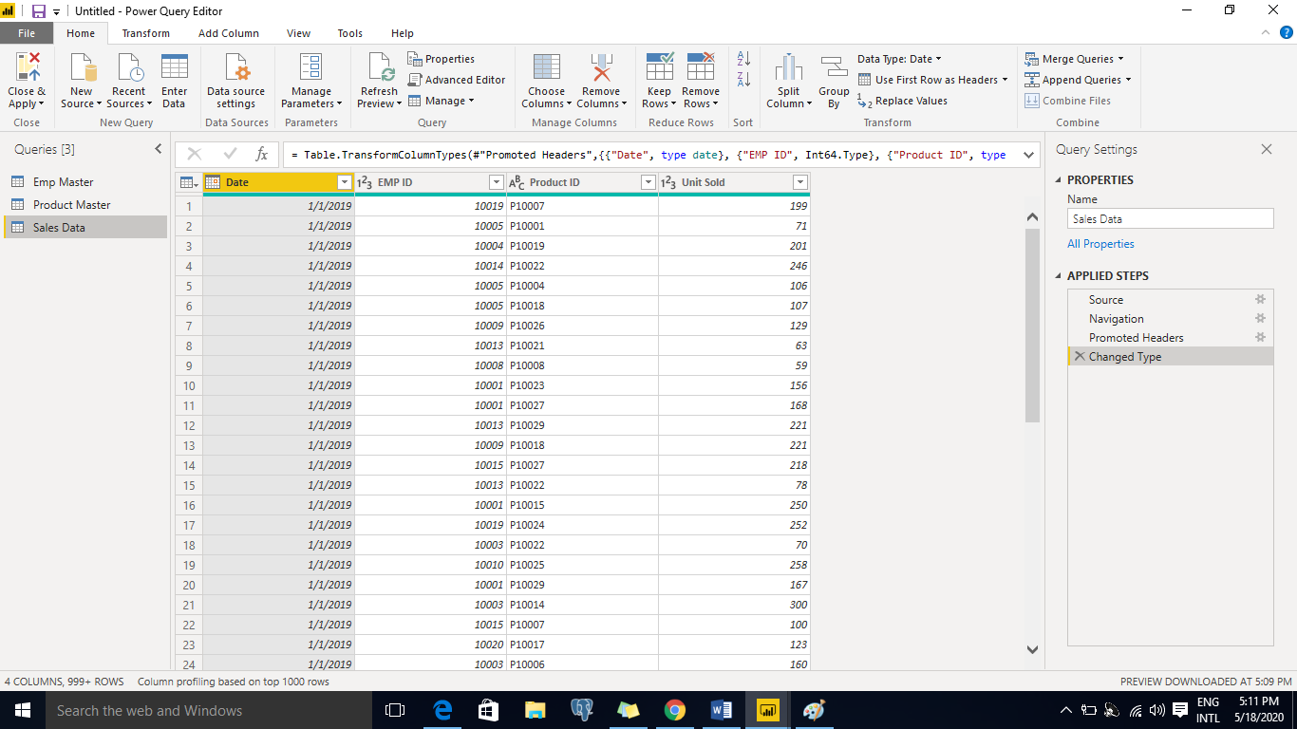

You have successfully completed import and data shaping operations and are ready to load the data into the Power BI Desktop data model which allows you to visualize the data.

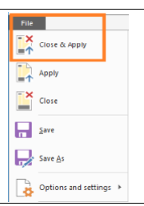

All the data will be loaded in memory within Power BI Desktop. You will see the progress dialog with the number of rows being loaded in each table as shown in the Figure.

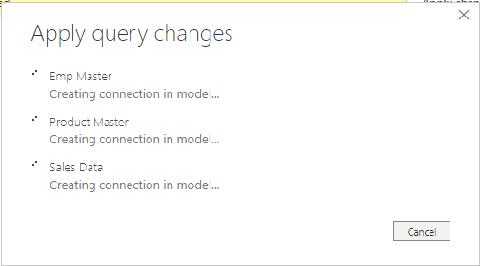

**Advanced Query Editor:**

To launch the **advanced editor**, select View from the ribbon, then select **Advanced Editor**. A window appears, showing the existing **query** code. You can directly edit the code in the **Advanced Editor** window. To close the window, select the done or cancel button.

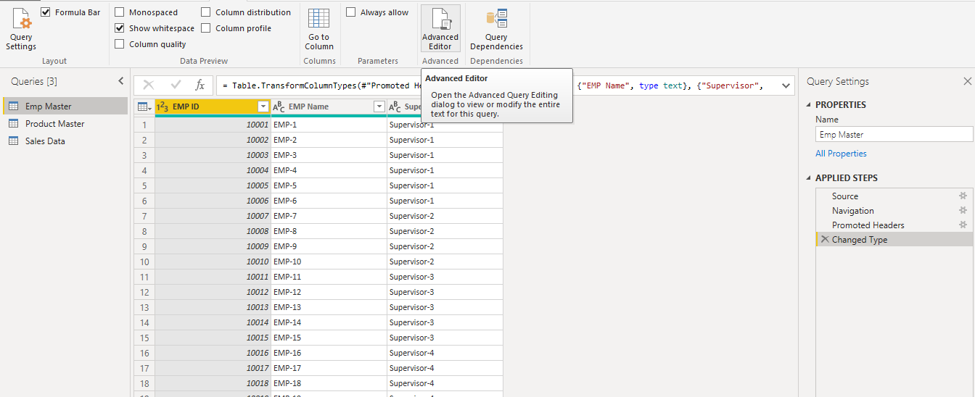

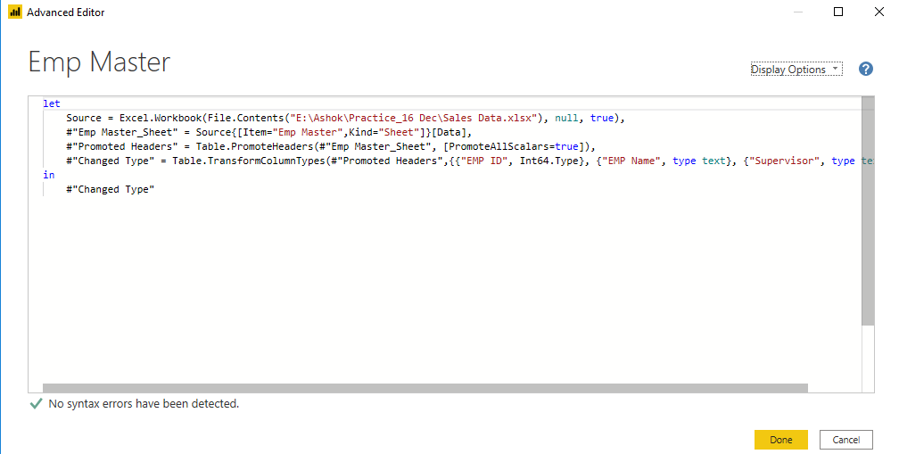

In Power BI on the left side of the screen, you have the following three tabs −

* Report
* Data
* Relationships

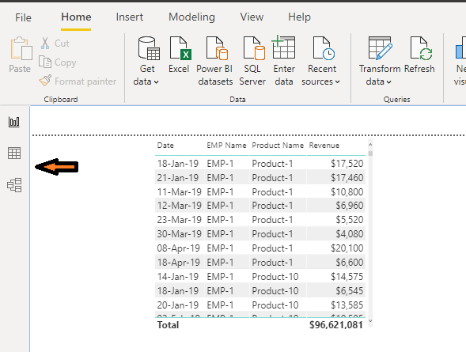

When you navigate to the Report tab, you can see a dashboard and a chart selected for data visualization. You can select different chart types as per your need. In our example, we have selected a Table type from available Visualizations.

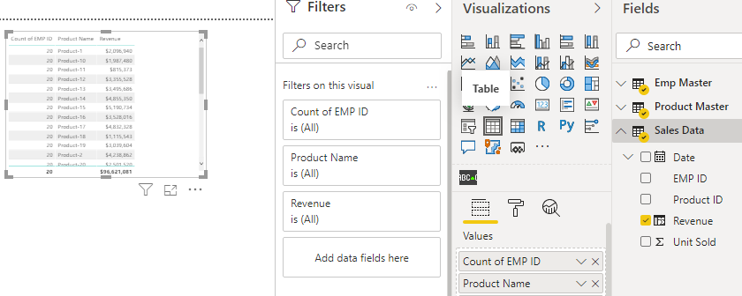

When you go to the Data tab, you can see all the data as per the defined Relationship from the data sources.

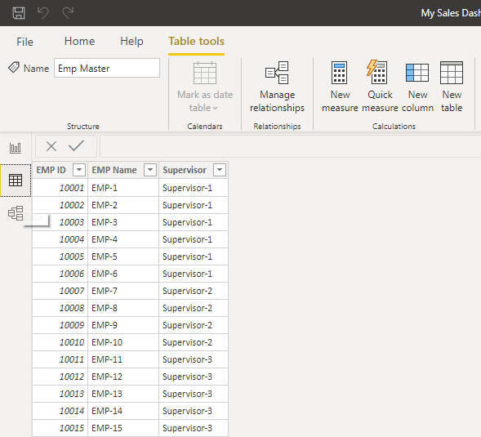

In the Relationship tab, you can see the relationship between data sources. When you add multiple data sources to Power BI visualization, the tool automatically tries to detect the relationship between the columns. When you navigate to the Relationship tab, you can view the relationship. You can also create a Relationship between the columns using Create Relationships option.

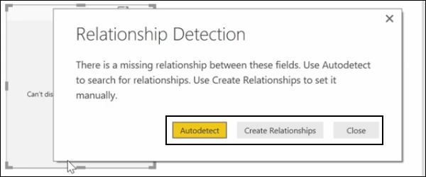

You can also add and remove relationships in data visualization. To remove a relationship, you have to right-click and select the “Delete” option. To create a new “Relationship”, you just need to drag and drop the fields that you want to link between the data sources.

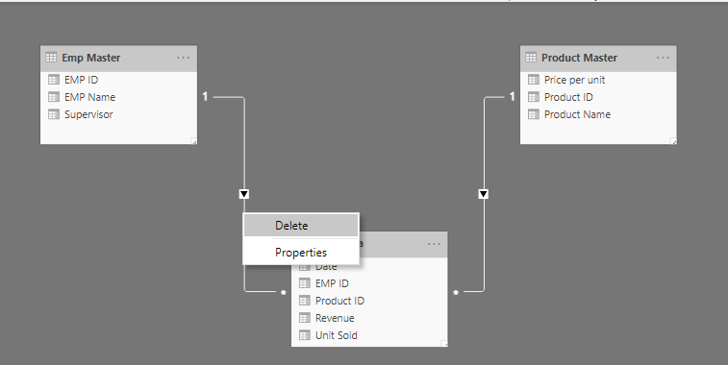

You can also use the Relationship view to hide a particular column in the report. To hide a column, right-click on the column name and select the “Hide in report view” option.

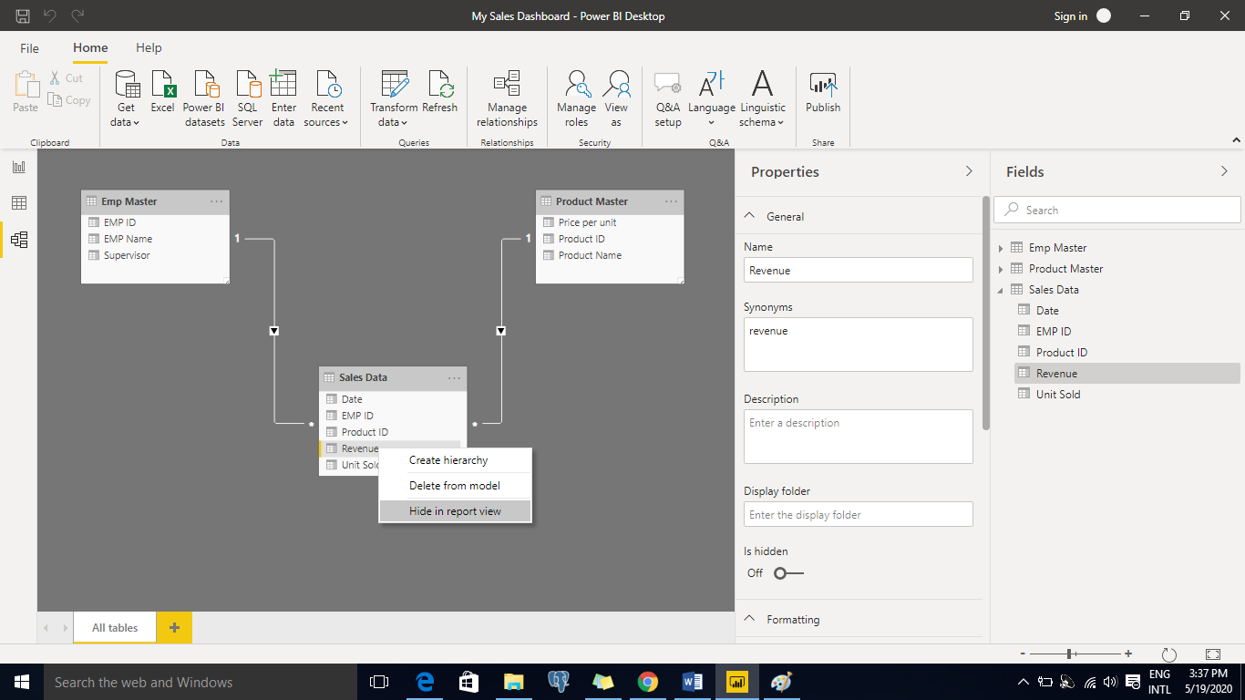

Details about Power BI Desktop, power BI Pro and power BI Premium as below

|  |  |  |  |
| --- | --- | --- | --- |
| **Features** | **Power BI Desktop** | **Power BI Pro** | **Power BI Premium** |
| On-premise reporting using Power BI Report Server | NO | No | Yes |
| Compute processing environment | NA | Shared | Dedicated |
| Incremental data refresh | NO | No | Yes |
| Share published reports | NO | Yes | No |
| Use paginated reports in Power BI | NO | No | Yes |
| Data set size (max) |  | 1GB | 10GB |
| Maximum allowed storage |  | 10 GB per user | 100TB |
| Cloud service |  | Yes | Yes |
| Data security and encryption |  | Yes | Yes |
| Create visualizations, reports, dashboards | Yes | Yes | Yes |
| Big Data preparation and ETL | Yes | Yes | Yes |
| Power BI library access and custom visuals SDK | Yes | Yes | Yes |
| Data connectors for cloud and on-premise sources |  | Yes | Yes |
| Analyze data in Microsoft Excel |  | Yes | Yes |
| Content embedding in SaaS apps like SharePoint, Teams, etc. | Yes | Yes | Yes |
| Mobile compatibility |  | Yes | Yes |
| Pricing | Free | $9.99 per month per user | $4,995 per month per instance |